LeetCode Program 2651
Link :- https://leetcode.com/problems/calculate-delayed-arrival-time/
Successful Submission
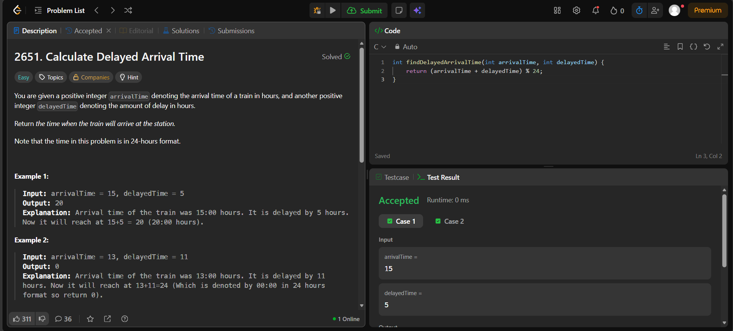
Source Code


